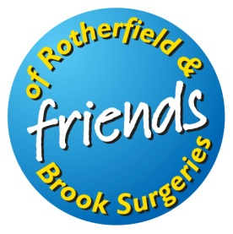

The League of Friends of the Rotherfield and Brook Surgeries

Registered Charity No. 802475

A warm thank you to everyone who supported this year’s Coffee Morning at Rotherfield Village Hall. It was good to be back after two years’ enforced absence, and to meet and chat with many old faces, as well as some welcome new ones.

A particular thank you to all those who set up and ran stalls, and of course to our sterling providers of coffees, teas and cakes, the vital ingredients to all our events.

Besides just enjoying the morning’s activities, I am delighted to say that we were able to add substantially to our funds. All the funds we raise are used to purchase much needed equipment to help our doctors, nurses and their staff to provide a full primary medical care service, and wherever possible to expand and extend that service, for the benefit of all patients of the Rotherfield and Brook Surgeries.

If you would like to become a Friend, please do contact me on 01892 852645 or email@andrewfermor.co.uk.

Andrew Fermor (Chairman)

