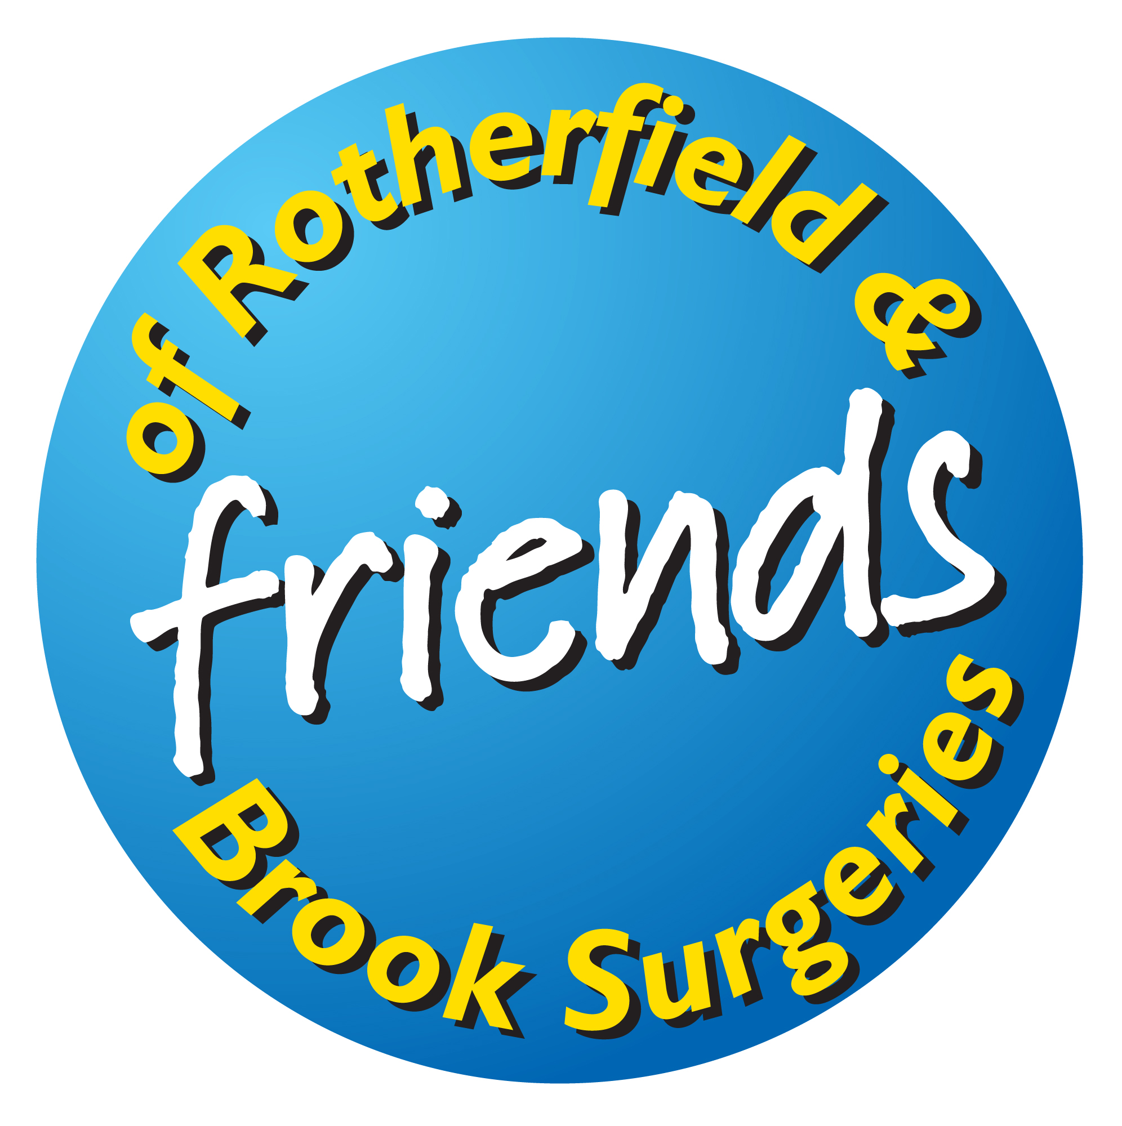

The League of Friends of the Rotherfield & Brook Surgeries

Registered Charity No. 802475

MEMBERSHIP APPLICATION

The League of Friends of the Rotherfield & Brook Surgeries exists to improve the health and well-being of patients at the two surgeries, mainly through the provision and maintenance of medical equipment to assist our GPs and nurses in diagnosis and treatment. Becoming a member of the League simply involves an annual subscription to contribute towards this, (the minimum subscription for individuals is £5, for couples and families £8). Please complete the form below, indicating your preferred method of payment and return it to me (not to your bank). If you are a UK tax payer, please also sign the gift-aid declaration which allows us to reclaim gift aid from HMRC.
Jeremy Cornford
Membership Secretary, The League of Friends of Rotherfield and Brook Surgeries
Barbers Cottage, High Street, Rotherfield TN6 3LJ
-------------------------------------------------------------------------------------------------------------------------------------------

Name(s)……………………………………………………………………………………………………………….Address……………………………………………………………………………………………………………….
………………………………………………………………………………………. Post Code……………………
Telephone………………………… E-mail………………………………………………………………………….
Annual Subscription (please tick): £5 [ ] £8 [ ] £10 [ ] £15 [ ] £20 [ ] £25 [ ] Other…………..
Part 1: Payment by Standing Order:
Name of Bank……………………………………………………………………… Sort Code…..........................
Bank Address…………………………………………………………………………...........................................
……………………………………………………………………………………….. Post Code…………………...
Account No………………………… Account Name(s)……………………………………………………………
Please pay to National Westminster Bank PLC, Sort Code 60-06-27, at 7 High Street, Crowborough, TN6 2PU, for the account of The League of Friends of the Rotherfield & Brook Surgeries, Account No 70352844, the sum of £……… (amount in words) ………………………………… on the (day)…………. of (month)…………………… (year)…………. and on the same day each year thereafter until further notice.

Signed…………………………………………………….. Date……………………….

Part 2: Payment by cheque/cash:

I enclose a cheque/cash to the sum of £……………
(Please make cheques payable to ‘The League of Friends of Rotherfield and Brook Surgeries.)

Part 3: Gift Aid Declaration:

Please treat all gifts of money that I make today and in the future as Gift Aid donations.
I confirm I have paid or will pay an amount of Income Tax and/or Capital Gains Tax for each tax year (6th April to 5th April) that is at least equal to the amount of tax that all the charities and CASCs that I donate to will reclaim on my gifts for that tax year. I understand that other taxes such as Council Tax and VAT do not count. I understand the charity will reclaim tax by way of gift aid on every £1 that I give.

Name………………………………………………………………………………………………………………….
Address……………………………………………………………………………………………………………….
……………………………………………………………………………………….Post Code……………………
Signature…………………………………………………Date…………………… Amount £………….

